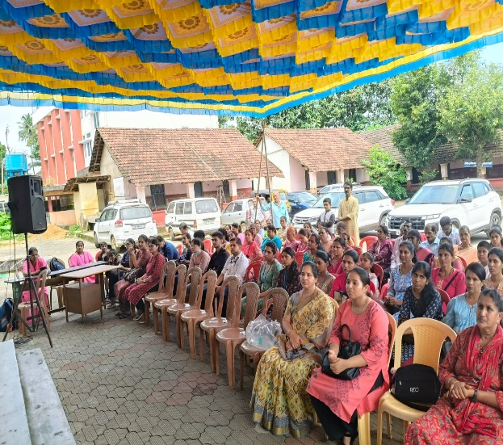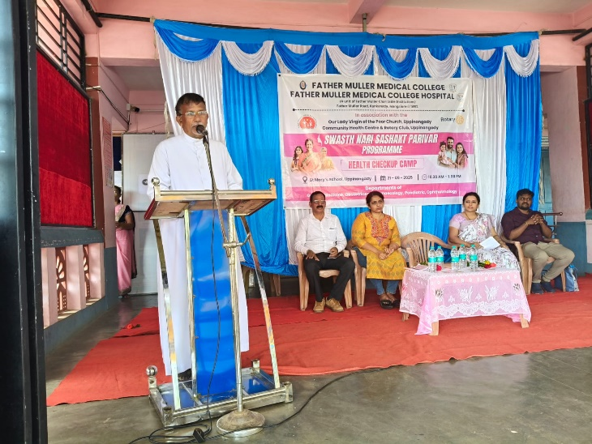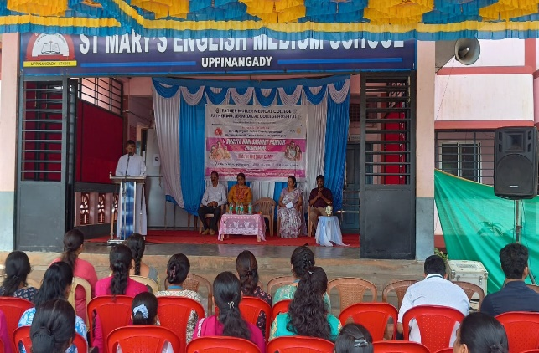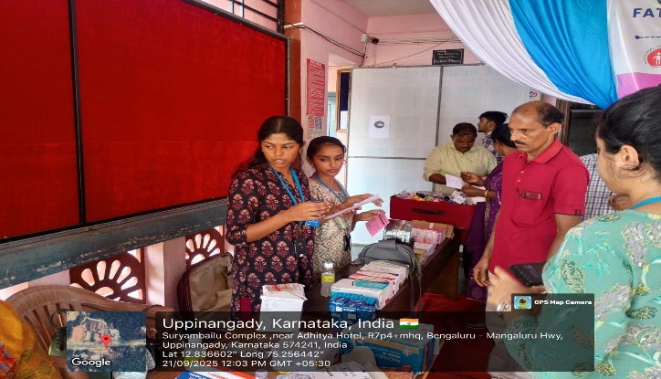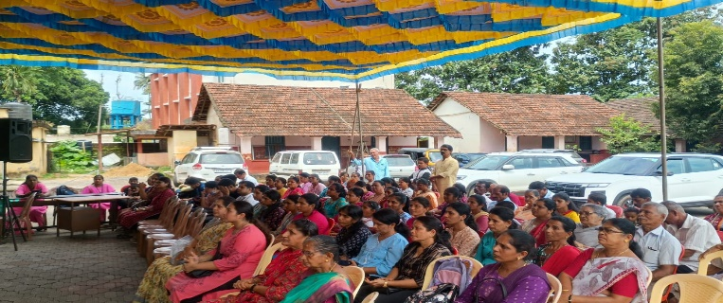

CAMP -02
Report on Swasth Nari, Sashakt Parivar Abhiyaan
On 21st September 2025, the Swasth Nari, Sashakt Parivar Abhiyaan camp was successfully conducted at Uppinangady Church, in collaboration with the Rotary Club, Uppinangady, and the Community Health Center, Uppinangady. The event witnessed enthusiastic participation, with nearly 150 participants attending the program.
The program was presided over by Rev. Fr. Jerald D’Souza, Parish Priest of Uppinangady Church. Mr. John Canute Menezes, President of the Rotary Club, Uppinangady, and Mr. Bharathesh S., Health Inspector at the Community Health Center, Uppinangady, were also present as dignitaries. Alongside them, several committed social workers participated and contributed to the success of the camp.

